4th Sunday after Pentecost

CHRIST LUTHERAN CHURCH | Lodi, California
June 25, 2023

WELCOME TO WORSHIP
Welcome to Christ Lutheran Church. We pray that your soul will be strengthened by the good news about God’s grace, love, and forgiveness given to us. If you would like to learn more about our church, please speak with our pastor or one of our members after the service.
- Bathrooms are located in the fellowship hall. A changing table is located in the women’s bathroom.
WORSHIP THEME
June 25 marks the anniversary of the presentation of the Augsburg Confession. On this day in 1530—in the city of Augsburg, Germany—the German princes and theologians presented their summary of the Christian faith as they confessed it. This summary is now the primary confession that sets the Lutheran Church apart from other denominations. Centered in Christ and focused on the free gift of salvation by grace through faith, the Augsburg Confession continues to shape what we believe, teach, and confess today.
Today’s service will present some of the foundational truths confessed by the Evangelical Lutheran Church: the three Solas. Named for the Latin words translated “alone,” they capture the core of our faith: we are saved by Grace Alone (Sola Gratia); God’s truth is revealed in Scripture Alone (Sola Scriptura); and we stand justified before God through Faith Alone (Sola Fide).

HYMN By Grace I’m Saved| CW 384

1 By grace I'm saved, grace free and boundless;

My soul, believe and doubt it not.

Why waver at this word of promise?

Has Scripture ever falsehood taught?

So then this word must true remain:

By grace you, too, shall heav'n obtain.

2 By grace God's Son, our only Savior,

Came down to earth to bear our sin.

Was it because of your own merit

That Jesus died, your soul to win?

No, it was grace, and grace alone,

That brought him from his heav'nly throne.

3 By grace! Oh, mark this word of promise

When you are by your sins oppressed,

When Satan plagues your troubled conscience,

And when your heart is seeking rest.

What reason cannot comprehend

God by his grace to you did send.

4 By grace to timid hearts that tremble,

In tribulation's furnace tried --

By grace, despite all fear and trouble,

The Father's heart is open wide.

Where could I help and strength secure

If grace were not my anchor sure?

Sola Gratia: we are saved by Grace alone. In fact, everything we receive from God is due to his grace. He desires our good and chooses to bless us simply because that is who he is: “the compassionate and gracious God, slow to anger, abounding in love and faithfulness, maintaining love to thousands, and forgiving wickedness, rebellion and sin.” (Exodus 34:6,7)
God’s grace is revealed to us as we begin in his name, trusting Jesus promise even to be with “two or three” who are gathered in his name. God’s grace is further showered upon us as we confess our sins and hear God’s unconditional announcement of forgiveness through the pastor.
INVOCATION
M: In the name of the Father, and of the Son ✙ and of the Holy Spirit
C: Amen.
CONFESSION
M: It is taught among us that since the fall of Adam, all human beings who are born in the natural way are conceived and born in sin. This means that from birth they are full of evil lust and inclination and cannot by nature possess true fear of God and true faith in God.
C: This original sin is truly sin and condemns to God’s eternal wrath all who are not born anew through baptism and the Holy Spirit.
M: It is taught that we cannot obtain forgiveness of sin and righteousness before God through our merit, work, or satisfactions, but that we receive forgiveness of sin and become righteous before God out of grace for Christ’s sake through faith when we believe that Christ has suffered for us and that for his sake our sin is forgiven and righteousness and eternal life are given to us.
C: For God will regard and reckon this faith as righteousness in his sight.
M: To obtain such faith God instituted the office of preaching, giving the gospel and the sacraments.
C: Through these, as through means, he gives the Holy Spirit who produces faith, where and when he wills, in those who hear the gospel.
M: Because of these truths, I invite you to confess your sins and hear God’s word of forgiveness.
C: Holy and merciful Father, I confess that I am by nature sinful, and that I have disobeyed you in my thoughts, words, and actions. I have done what is evil and failed to do what is good. For this I deserve your punishment both now and in eternity. But I am truly sorry for my sins, and trusting in my Savior Jesus Christ, I pray: Lord, have mercy on me, a sinner.

M: God, our heavenly Father, has been merciful to us and has given his only Son to be the atoning sacrifice for our sins. Therefore, as a called servant of Christ and by his authority, I forgive you all your sins in the name of the Father and of the Son ✙ and of the Holy Spirit.
C: Amen
M: In the peace of forgiveness, let us praise the Lord.
(Sung) By grace! On this I'll rest when dying;
In Jesus' promise I rejoice.
For though I know my heart's condition,
I also know my Savior's voice.
My heart is glad; all grief has flown
Since I am saved by grace alone.

PRAYER OF THE DAY
M: The Lord be with you.
C: And also with you.
M: Let us pray.
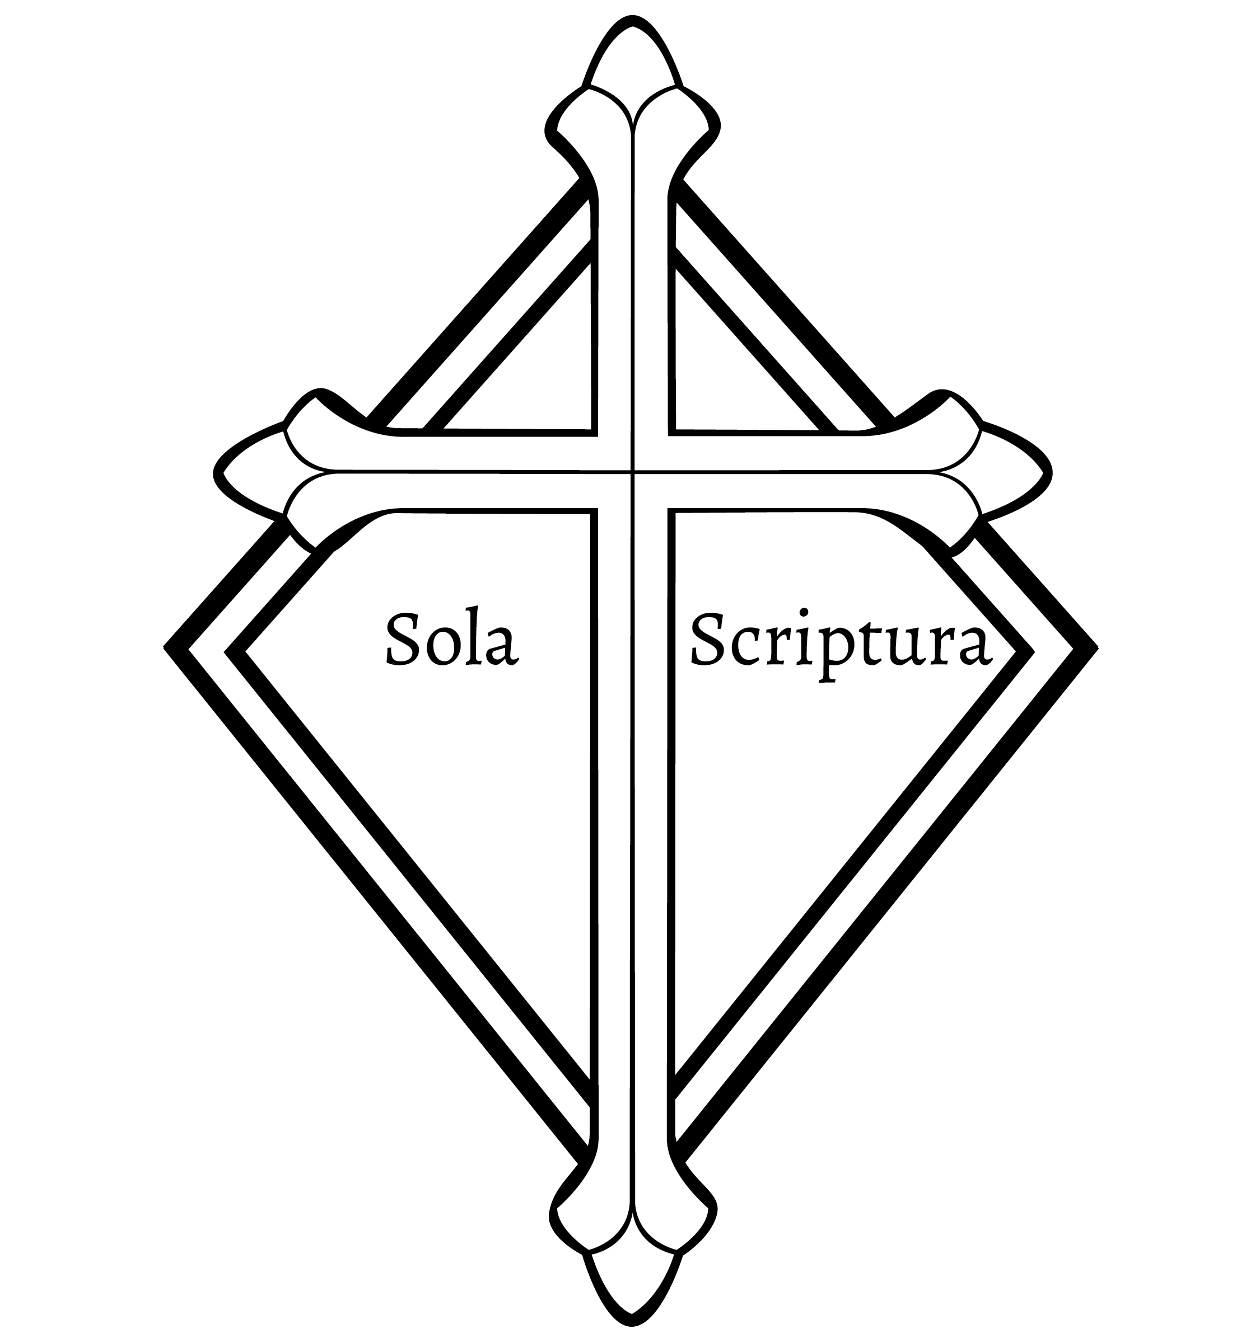
O Lord, favorably receive the prayers of your Church, that being instructed by the doctrine of the blessed apostles, we may always make a pure confession of your saving truth; through Jesus Christ, your Son, our Lord, who lives and reigns with you and the Holy Spirit, one God, now and forever.
C: Amen.

Sola Scriptura: God’s word as recorded in the Bible is the only reliable guide for our faith and Christian life. All other words or instructions that we might receive will let us down. But praise the Lord that he has preserved his Word and allowed it to come to us.

FIRST LESSON Isaiah 55:6–13
The Word of the Lord comes down like snow and rain from heaven to bring abundant blessings upon the people of the earth. Though we might not understand all of God’s Ways, what comes down to us is full of grace and mercy.
⁶ Seek the Lord while he may be found; call on him while he is near.
⁷ Let the wicked forsake their ways and the unrighteous their thoughts.
Let them turn to the Lord, and he will have mercy on them,
and to our God, for he will freely pardon.
⁸ “For my thoughts are not your thoughts, neither are your ways my ways,”
declares the Lord.
⁹ “As the heavens are higher than the earth, so are my ways higher than your ways
and my thoughts than your thoughts.
¹⁰ As the rain and the snow come down from heaven, and do not return to it
without watering the earth and making it bud and flourish,
so that it yields seed for the sower and bread for the eater,
¹¹ so is my word that goes out from my mouth: It will not return to me empty,
but will accomplish what I desire and achieve the purpose for which I sent it.
¹² You will go out in joy and be led forth in peace;
the mountains and hills will burst into song before you,
and all the trees of the field will clap their hands.
¹³ Instead of the thornbush will grow the juniper,
and instead of briers the myrtle will grow.
This will be for the Lord’s renown,
for an everlasting sign, that will endure forever.”
PSALM Psalm 119a, pg. 109
SECOND LESSON Romans 10:5–17
Faith comes from hearing, and the faith we hold in our hearts we now confess with our mouths.
⁵ Moses writes this about the righteousness that is by the law: “The person who does these things will live by them.” ⁶ But the righteousness that is by faith says: “Do not say in your heart, ‘Who will ascend into heaven?’” (that is, to bring Christ down) ⁷ “or ‘Who will descend into the deep?’” (that is, to bring Christ up from the dead). ⁸ But what does it say? “The word is near you; it is in your mouth and in your heart,” that is, the message concerning faith that we proclaim: ⁹ If you declare with your mouth, “Jesus is Lord,” and believe in your heart that God raised him from the dead, you will be saved.
¹⁰ For it is with your heart that you believe and are justified, and it is with your mouth that you profess your faith and are saved. ¹¹ As Scripture says, “Anyone who believes in him will never be put to shame.” ¹² For there is no difference between Jew and Gentile—the same Lord is Lord of all and richly blesses all who call on him, ¹³ for, “Everyone who calls on the name of the Lord will be saved.”
¹⁴ How, then, can they call on the one they have not believed in? And how can they believe in the one of whom they have not heard? And how can they hear without someone preaching to them? ¹⁵ And how can anyone preach unless they are sent? As it is written: “How beautiful are the feet of those who bring good news!”^{[ 16} But not all the Israelites accepted the good news. For Isaiah says, “Lord, who has believed our message?” ¹⁷ Consequently, faith comes from hearing the message, and the message is heard through the word about Christ.
VERSE OF THE DAY Isaiah 40:8
Alleluia. The grass withers and the flowers fall,
but the word of our God endures forever.” Alleluia.
The Latin translation of this verse (VERBUM DEI MANET IN AETERNUM) became the motto of the Reformation. The symbol VDMA placed around the cross is considered the symbol of the Lutheran Reformation.

THE GOSPEL Matthew 10:32–39
Those who confess Christ before the world will be welcomed by Christ into eternal life in the new heavens and the new earth.
³² “Whoever acknowledges me before others, I will also acknowledge before my Father in heaven. ³³ But whoever disowns me before others, I will disown before my Father in heaven.
³⁴ “Do not suppose that I have come to bring peace to the earth. I did not come to bring peace, but a sword. ³⁵ For I have come to turn
“‘a man against his father,
a daughter against her mother,
a daughter-in-law against her mother-in-law—
³⁶ a man’s enemies will be the members of his own household.’

³⁷ “Anyone who loves their father or mother more than me is not worthy of me; anyone who loves their son or daughter more than me is not worthy of me. ³⁸ Whoever does not take up their cross and follow me is not worthy of me. ³⁹ Whoever finds their life will lose it, and whoever loses their life for my sake will find it.
M This is the Gospel of the Lord.
C: Praise be to you, O Christ!

HYMN OF THE DAY A Mighty Fortress is Our God| CW 201

1 A mighty fortress is our God, 2 With might of ours can naught be done;

A trusty shield and weapon; Soon were our loss effected.

He helps us free from ev’ry need But for us fights the valiant one

That has us now o’ertaken. Whom God himself elected.

The old evil foe You ask, “Who is this?”

Now means deadly woe; Jesus Christ it is,

Deep guile and great might The almighty Lord.

Are his dread arms in fight; And there’s no other God;

On earth is not his equal. He holds the field forever.

3 Though devils all the world should fill, 4 The Word they still shall let remain,

All eager to devour us, Nor any thanks have for it;

We tremble not, we fear no ill; He’s by our side upon the plain

They shall not overpow’r us. With his good gifts and Spirit.

This world’s prince may still And do what they will—

Scowl fierce as he will, Hate, steal, hurt, or kill—

He can harm us none. Though all may be gone,

He’s judged; the deed is done! Our victory is won;

One little word can fell him. The kingdom’s ours forever!

SERMON Romans 8:1–4
Therefore, there is now no condemnation for those who are in Christ Jesus, because through Christ Jesus the law of the Spirit who gives life has set you free from the law of sin and death. For what the law was powerless to do because it was weakened by the flesh, God did by sending his own Son in the likeness of sinful flesh to be a sin offering. And so he condemned sin in the flesh, in order that the righteous requirement of the law might be fully met in us, who do not live according to the flesh but according to the Spirit.

________________________________________________________
Sola Fide: When we hear the gospel from God’s Word and learn of his grace, we receive what he promises through faith. Now that we trust that God has spoken the truth, we respond with fruits of faith: we sing God’s praise, bring him our thankful and heartfelt offerings, and pray for God’s continued blessing on ourselves and our world.
SONG OF PRAISE
God’s Word is our great heritage
And shall be ours forever;
To spread its light from age to age
Shall be our chief endeavor.
Through life it guides our way;
In death it is our stay.
Lord, grant, while worlds endure,
We keep its teachings pure
Throughout all generations.
OFFERING
In response to God’s love and forgiveness, we give back a portion of what he has given us. The members of Christ Lutheran Church have joined to proclaim the gospel to this community. These offerings support that work. While our guests are welcome to participate, they should not feel obligated to do so.

Apostles’ Creed
I believe in God, the Father Almighty,
maker of heaven and earth.
I believe in Jesus Christ, his only Son, our Lord,
who was conceived by the Holy Spirit,
born of the Virgin Mary,
suffered under Pontius Pilate,
was crucified, died, and was buried.
He descended into hell.
The third day he rose again from the dead.
He ascended into heaven
and is seated at the right hand of God the Father Almighty.
From there he will come to judge the living and the dead.
I believe in the Holy Spirit,
the holy Christian Church,
the communion of saints,
the forgiveness of sins,
the resurrection of the body,
and the life everlasting. Amen.

PRAYER OF THE CHURCH
M: Almighty and eternal God, when the time had fully come, you sent your Son to take our place under the demands of the law and to endure the just punishment for our sins. For our sakes you accepted his sacrifice on the cross and raised him from death to glorious splendor.
C: Praise the Lord, my soul, and forget not all his benefits.
M: When the time had fully come, you bestowed your Spirit on your people as a testimony that you had called them to proclaim the gospel to every creature. Equipped and encouraged, they carried the Word of salvation into all the world.
C: The Lord reigns. Let the earth be glad; let the distant shores rejoice.
M: When the time had fully come, you raised up your servants, the Lutheran reformers, to restore the pure and right teaching of the Scriptures to a troubled Church. You renewed your people with the light of your love, and your holy church grew and prospered throughout the world.
C: God is our refuge and strength, an ever-present help in trouble.
M: When the time had fully come, you made our forefathers bold to take their stand on the truth of your Word. You have blessed their sons and daughters and have enabled us to preserve and proclaim the saving gospel.
C: Sing to the Lord, for he has done glorious things; let this be known to all the world.
M: Let this be a time, O Lord, when you renew us again by Word and sacrament, when you reform our hearts and minds, and when you restore to us the joy of fellowship and service. Grant to us in this age and in this place the courage of the apostles, the steadfastness of the reformers, and the dedication of those who have gone before us.
C: May the Lord our God be with us as he was with our fathers; may he never leave us nor forsake us.
M: Let this be a time, O Lord, when we recommit and re-consecrate ourselves to the ministry of the gospel. Let us find joy in our unity, zeal for our work, and success in our labor.
C: May God be gracious to us and bless us and make his face shine on us, that his ways may be known on earth, his salvation among all nations.

LORD’S PRAYER Matthew 6:9-13; Luke 11:2-4
C: Our Father in heaven,
hallowed be your name,
your kingdom come,
your will be done on earth as in heaven.
Give us today our daily bread;
and forgive us our sins,
as we forgive those
who sin against us;
and lead us not into temptation,
but deliver us from evil.
For the kingdom
and the power and the glory are yours
now and forever. Amen.

M: Almighty God, grant to your Church the Holy Spirit and the wisdom that comes from above. Let nothing hinder your Word from being freely proclaimed to the joy and edifying of Christ’s holy people, so that we may serve you in steadfast faith and confess your name as long as we live, through Jesus Christ, our Lord, who lives and reigns with you and the Holy Spirit, one God, now and forever.
C: Amen.

THE BLESSING
M: The Lord bless you and keep you.
The Lord make his face shine on you and be gracious to you.
The Lord look on you with favor and ✙ give you peace.
C: Amen.

CLOSING HYMN Oh For a Faith that Will Not Shrink | CW 405

1 Oh, for a faith that will not shrink 2 That will not murmur nor complain

Though pressed by many a foe, Beneath the chast’ning rod,

That will not tremble on the brink But in the hour of grief or pain

Of poverty or woe, Can lean upon its God,

3 A faith that shines more bright and clear 4 That bears unmoved the world’s dread frown

When tempests rage without, Nor heeds its scornful smile,

That, when in danger, knows no fear, That sin’s wild ocean cannot drown

In darkness feels no doubt, Nor Satan’s arts beguile,

5 A faith that keeps the narrow way 6 Lord, give us such a faith as this,

Till life’s last spark is fled And then, whate’er may come,

And with a pure and heav’nly ray We’ll taste e’en now the hallowed bliss

Lights up the dying bed. Of an eternal home.

WELCOME TO CHRIST EV. LUTHERAN CHURCH!
We preach a message of forgiveness, hope and peace
through the death and resurrection of Jesus Christ.
Families and individuals of all ages will find opportunities
both to grow and to serve.
Our mission statement:
Look what Christ is doing!
He binds us together in fellowship
He gathers us in for worship
He builds us up for service
He sends us out with the gospel

“Now you are the body of Christ,
and each one of you is a part of it.”
(1 Corinthians 12:27)

COPYRIGHT INFORMATION
Content requiring a copyright license is reproduced under OneLicense.net #A-718312. All rights reserved. The Common Service: Texts revised from The Lutheran Hymnal, 1941. Music revised by James Engel. Scripture Quotations: From the Holy Bible, New International Version (NIV 1984), © 1973, 1978, 1984 by Biblica, Inc.

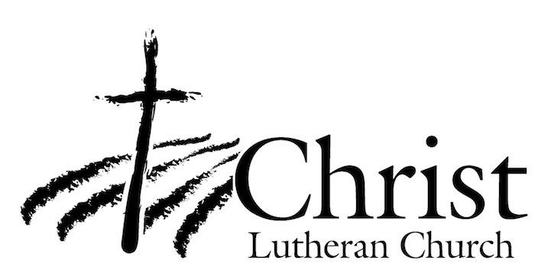
13009 N. Elderberry Ct.
Lodi, CA 95242
www.christlodi.org
209-368-6250
Pastor Tim Leistekow

